REGIONAL ACADEMY ON THE UNITED NATIONS (RAUN)
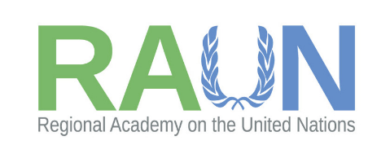
UN GENERAL KNOWLEDGE QUESTIONS

- Who is the current United Nations’ Secretary-General and who did he replace?
- Antonio Guterres since 2016, he succeeded Ban Ki-Moon (2007-2016)

- The document that established the United Nations is called …UN charter…………….. signed on ………… 26 June 1945

- Name the main purposes of the United Nations
- purpose of maintaining international peace and security,
- to develop friendly relations among states,
- to promote international cooperation,
- and to serve as a centre for harmonizing the actions of states in achieving those goals.

- How many Member States does the United Nations have?
- 193 member states and 2 observer states

- Which country became the latest member of the United Nations?
- South Sudan

- List the main bodies of the United Nations and their main function
The UN comprises six principal organizations:
- the General Assembly,
- the Security Council,
- the Economic and Social Council,
- the International Court of Justice,
- the Secretariat,
- the Trusteeship Council which,
together with several specialized agencies and related agencies, make up the United Nations System.

- List the 4 UN Headquarters:
- Vienna
- Geneva
- Nairobi
- New York

- How many Sustainable Development Goals (SDGs) are there?
- 17 SDGs

